Micro Services:

<https://www.youtube.com/watch?v=y8IQb4ofjDo&list=PLqq-6Pq4lTTZSKAFG6aCDVDP86Qx4lNas&index=2&t=0s>

Video 5:

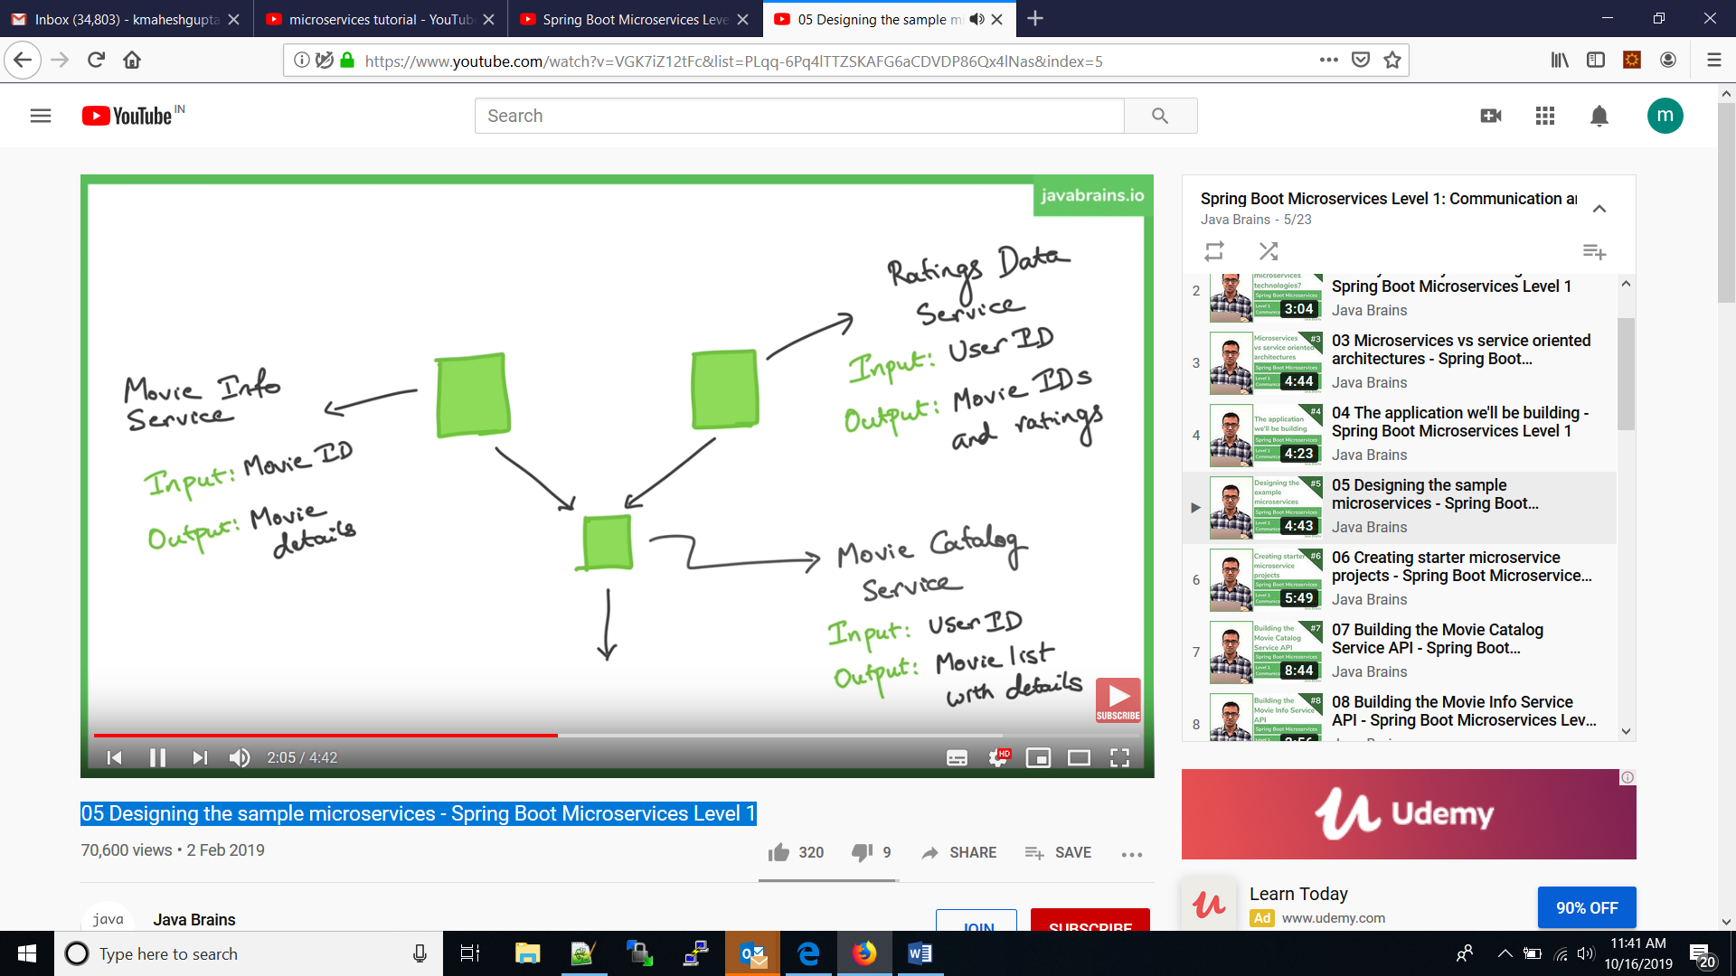

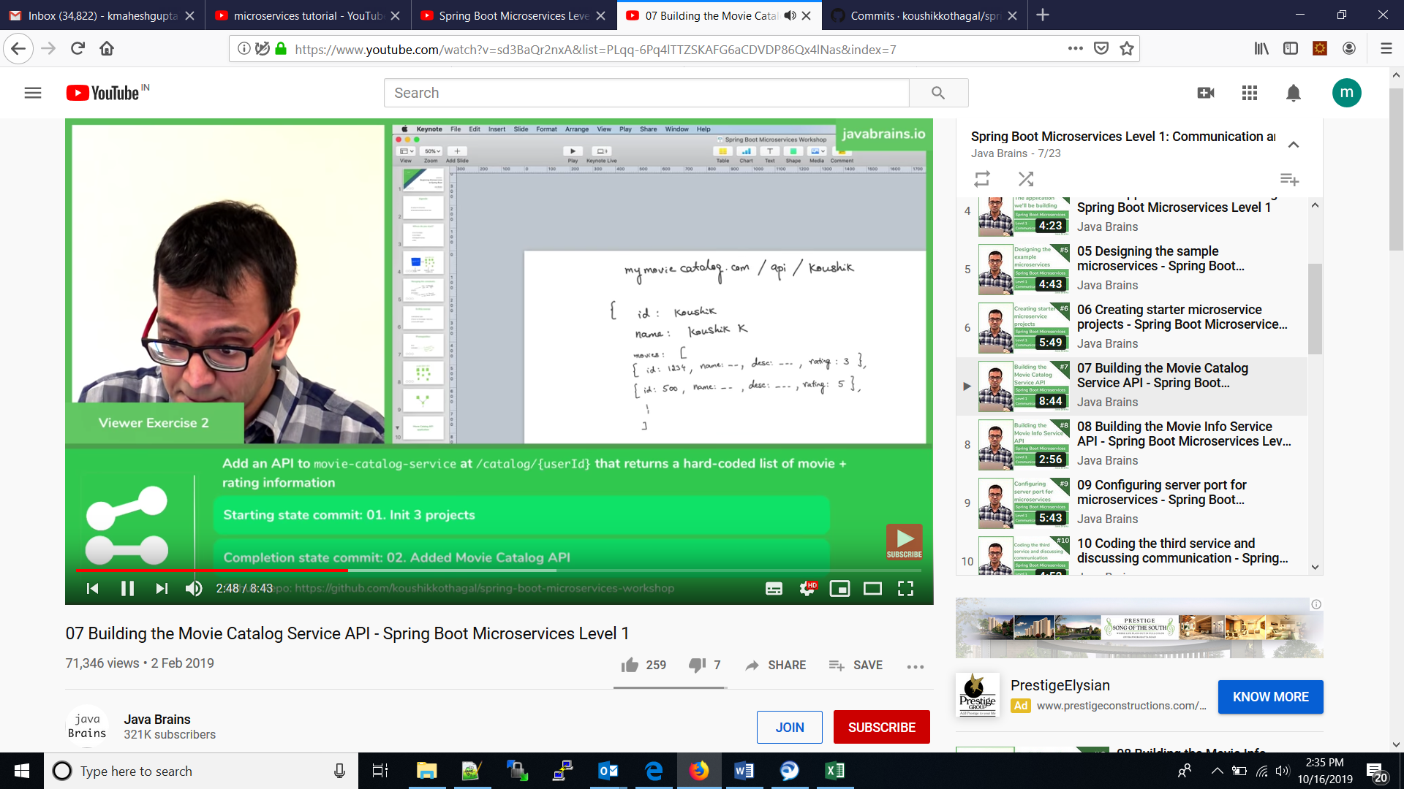

Video 10:

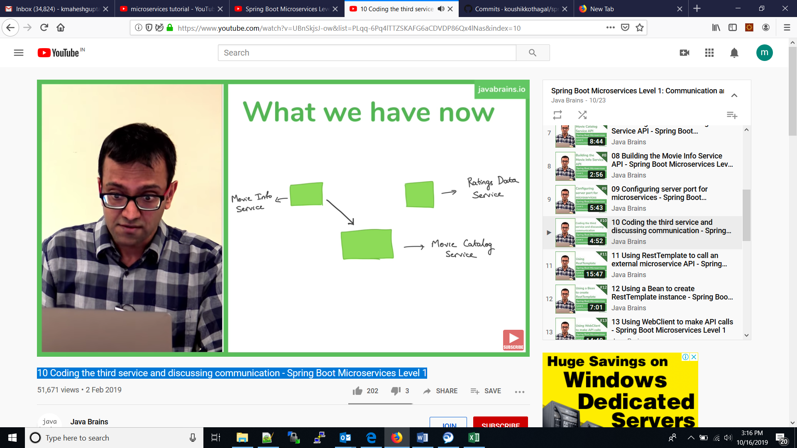

Calling movieinfo api from movie catalog micro service

Video : 17

Client side discovery: - spring cloud -

1. client send the request to discovery server with input like to which service it has to call

2. discovery server will respond with server detail to which server client should use.

3. Based on discovery server response, **client directly calls the service server.**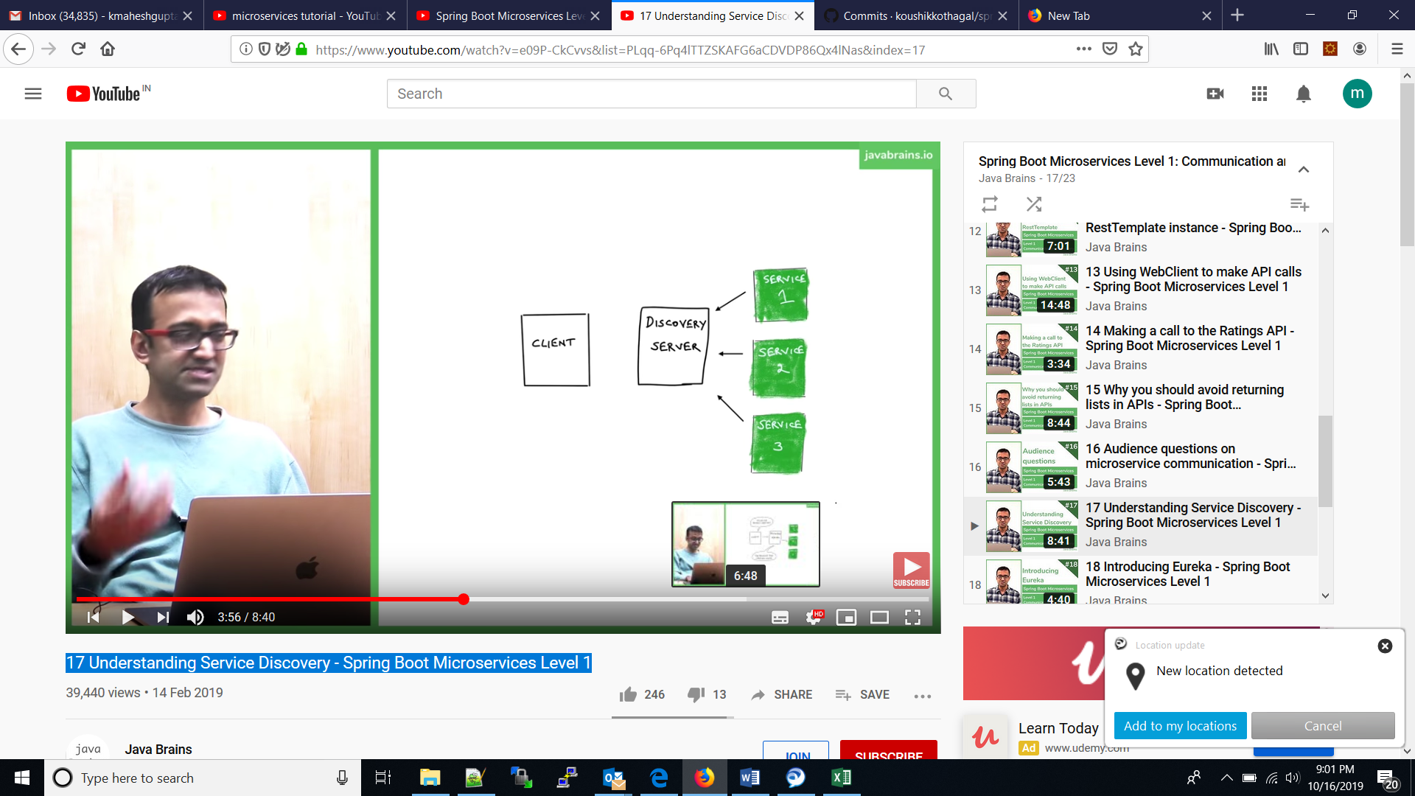

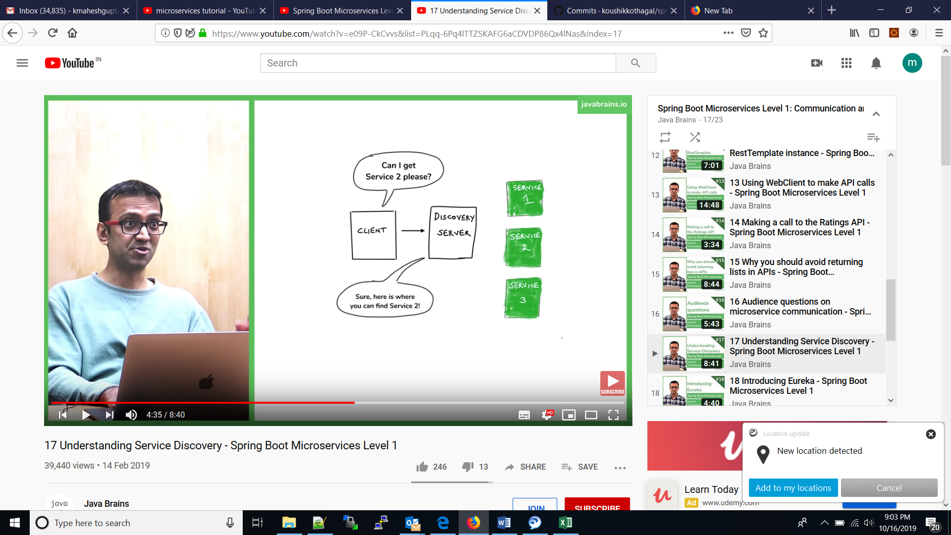

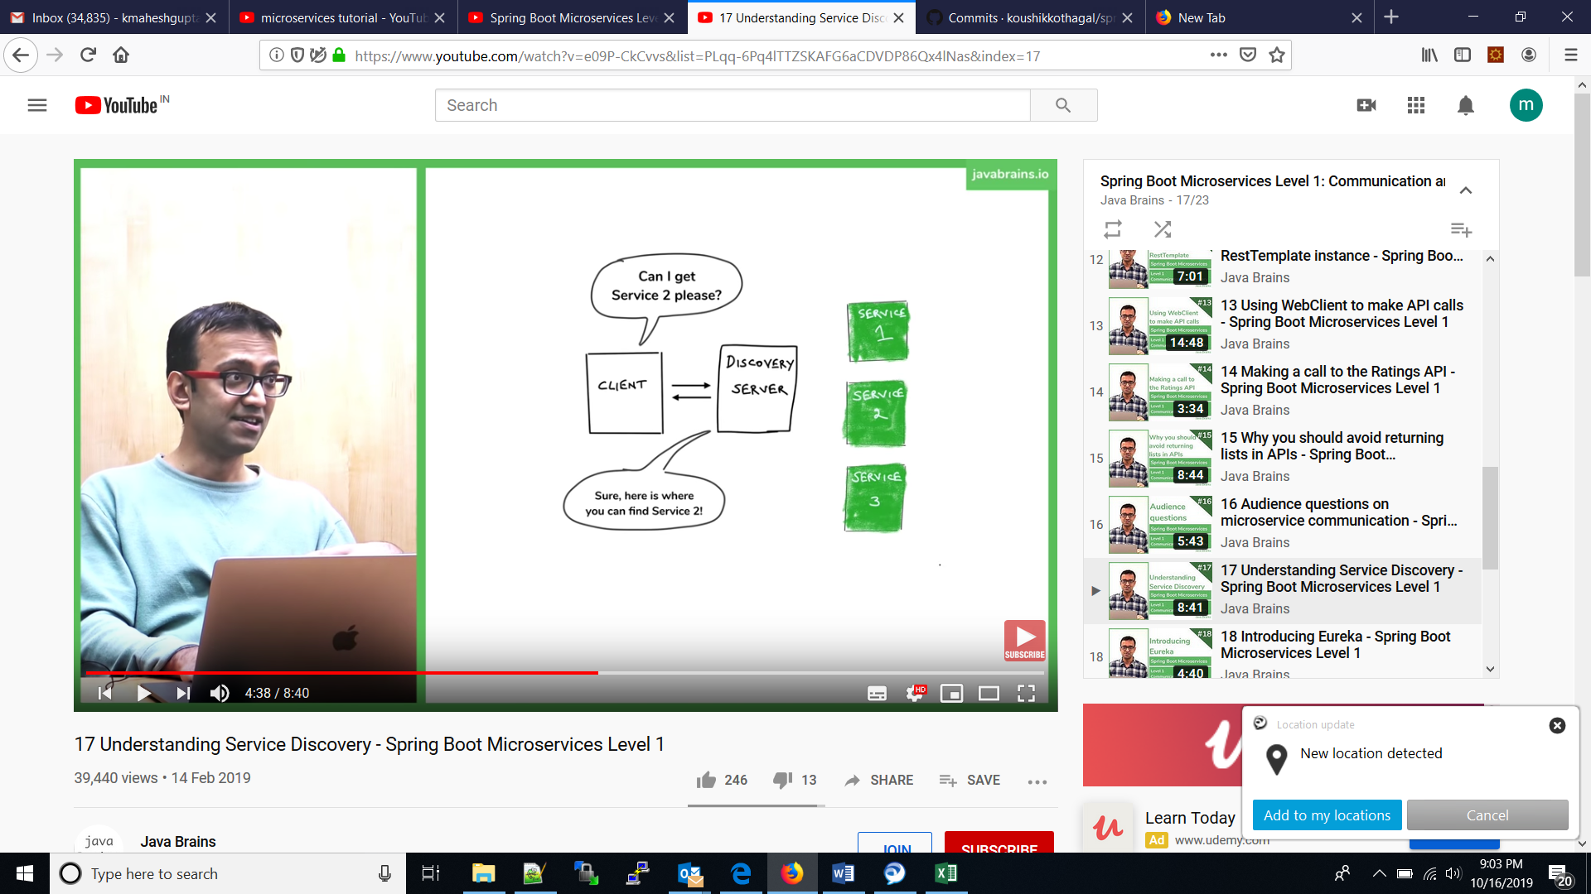

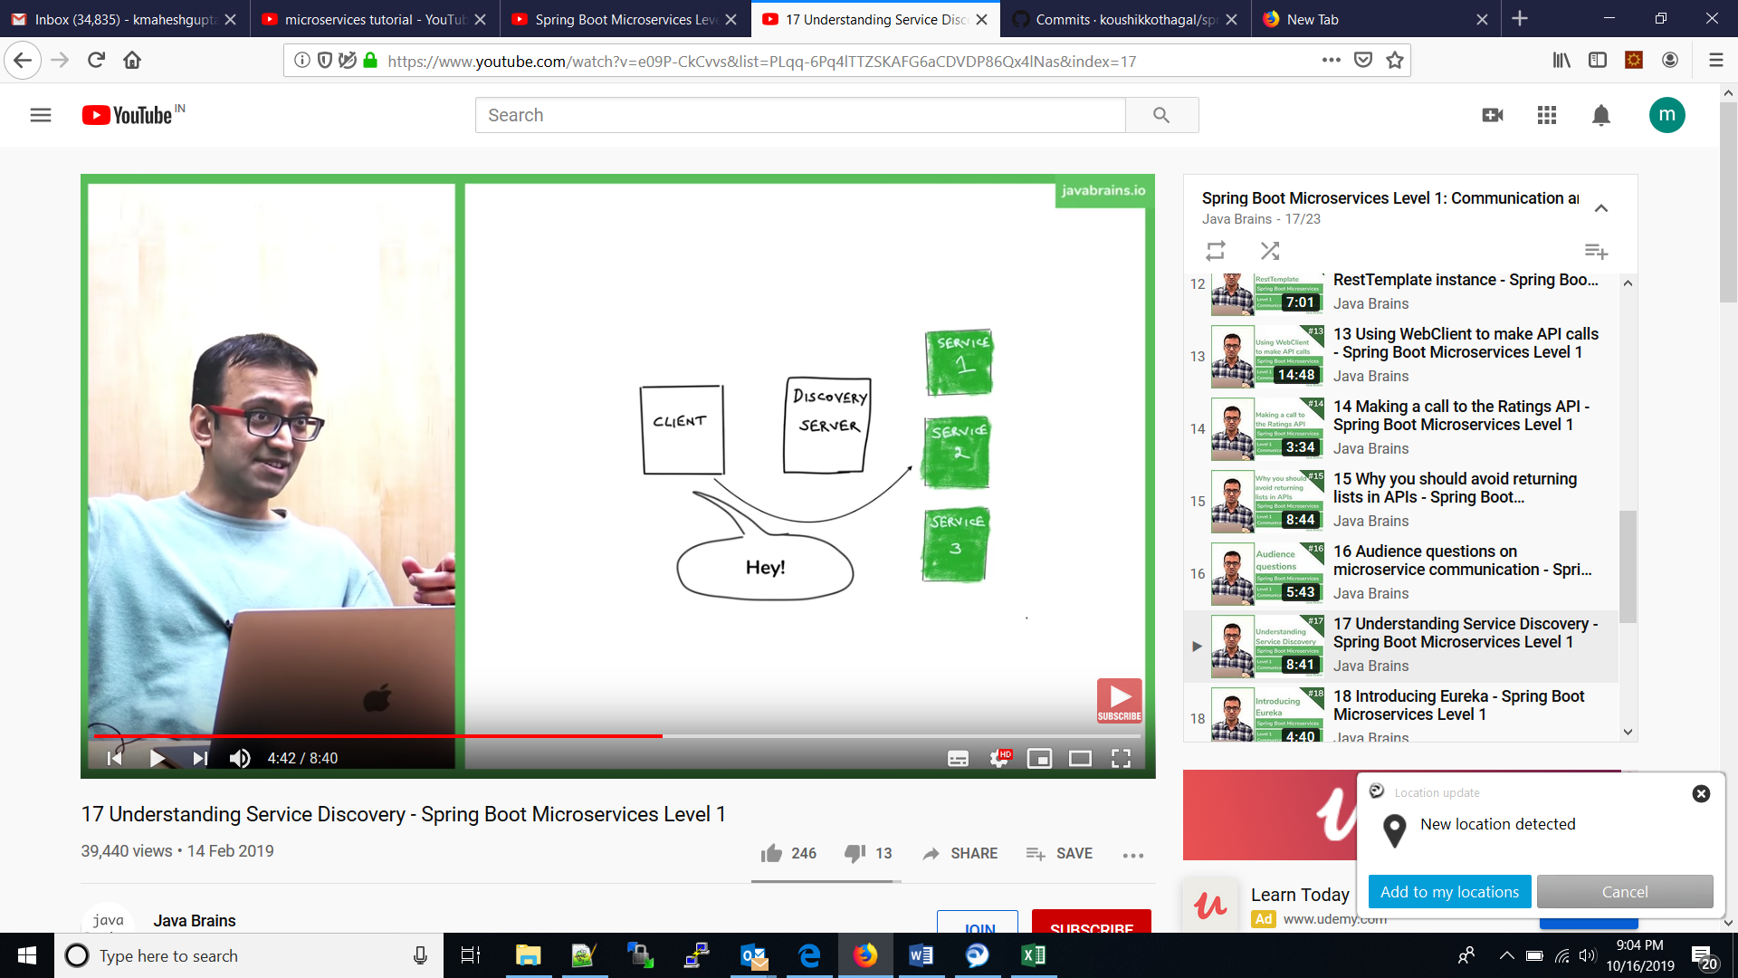

Server side discovery:

1. Client calls the discovery server
2. Discovery server calls the service server to serve the response.

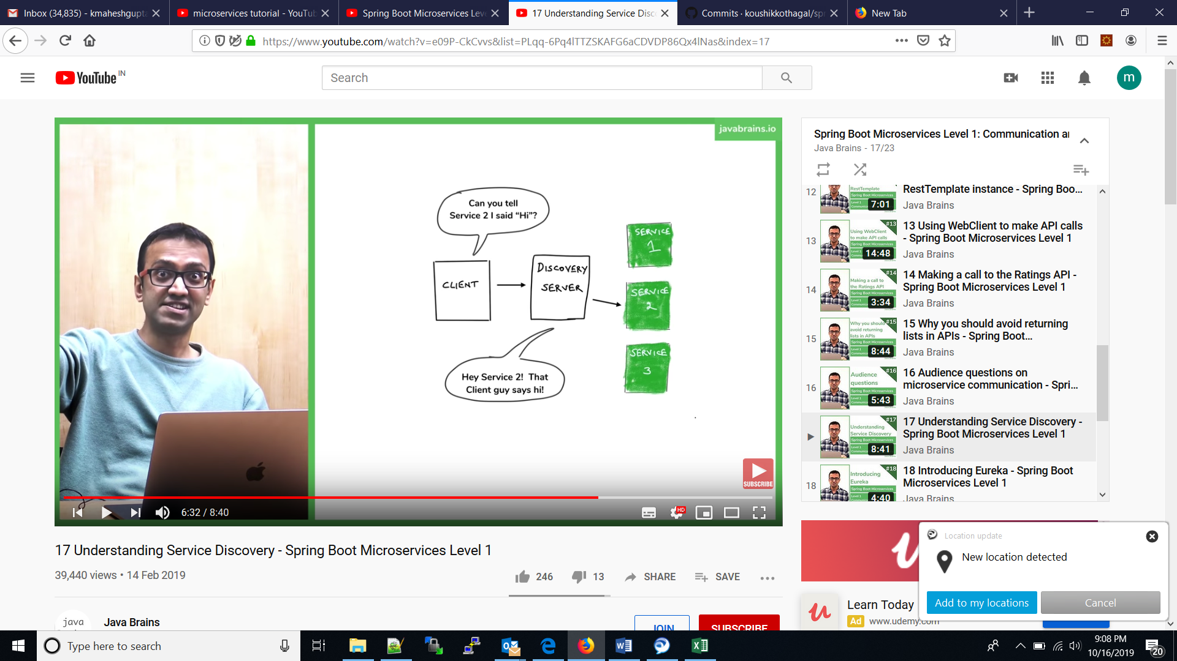

Video :

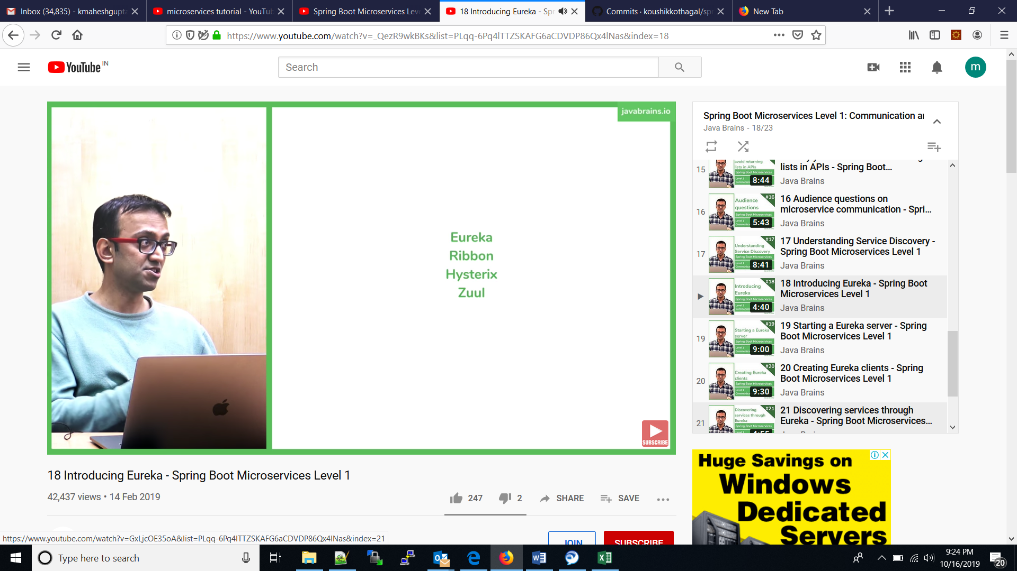

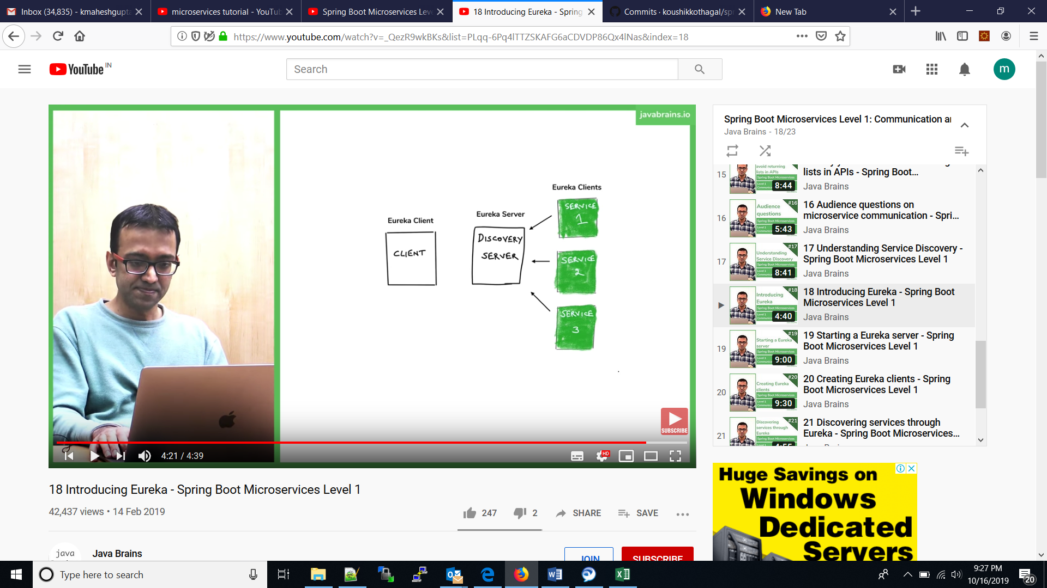

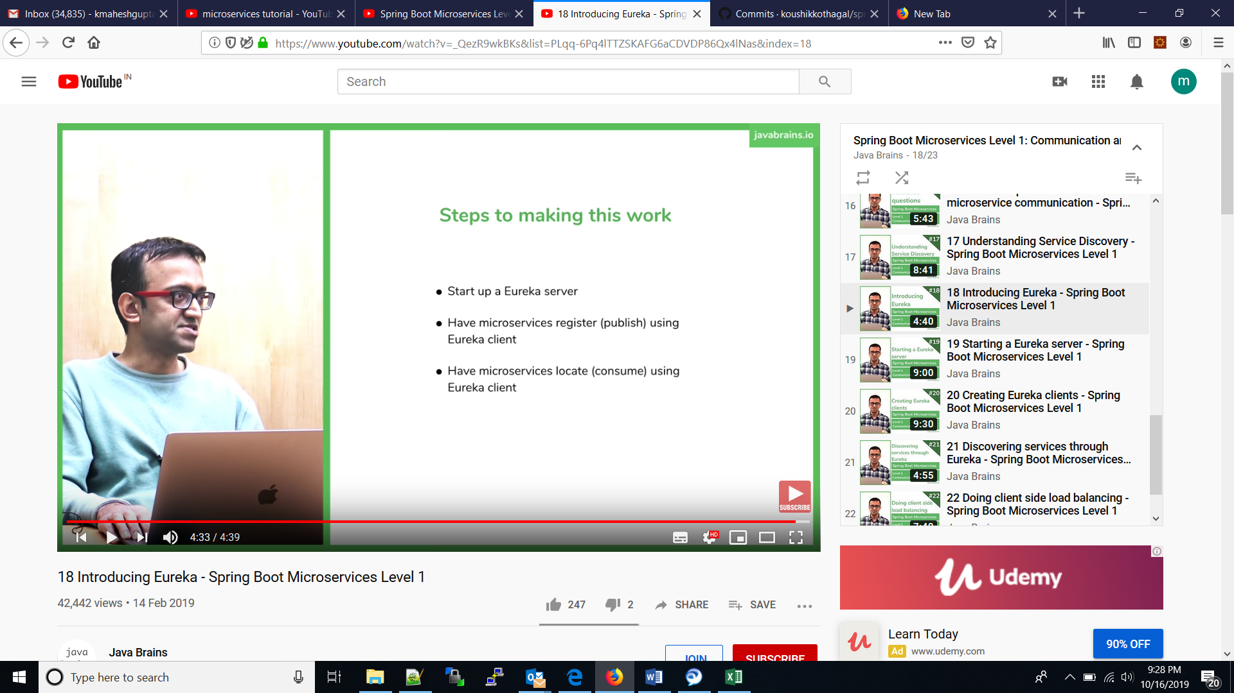

Video : 22:

If you have multiple pods/servers for a particular service.

